[AI-Based Predictive Content Recommendation for OTT Platforms](https://jyothirraghavalu369.atlassian.net/browse/BJR)

Jyothir Raghavalu Bhogi School of Computer Sciences Lovely Professional University Phagwara, India

[jyothirraghavalu369@gmail.com](mailto:jyothirraghavalu369@gmail.com)

Kakarla Adi Kesava Reddy School of Computer Sciences Lovely Professional University Phagwara, India [adikesavareddykakarla@gmail.co](mailto:adikesavareddykakarla@gmail.co) m

Deepak Gade

School of Computer Sciences Lovely Professional University Phagwara, India [gadedeepak517@gmial.com](mailto:gadedeepak517@gmial.com)

# *Abstract*— For starters, counterfeit insights has figured into major changes concerning the changes made in substance generation, personalization, and group of onlookers engagement in media and entertainment.

# Further, the inquire about explores the developing impact of AIs and their put within the present day media age as well as their potential impacts on human decision-making. It goes a step encourage to consider the moral suggestions at that level. The ponder hence collects different pieces of prove for the blend of the discoveries and sets them out whereas advertising a few common picture over the benefits and challenges coming about from the utilize of AI in advanced media, gaming, and book distributing and motion picture suggestion frameworks. At last, it sets up where consumerism, believe, and cognition f it with the nearness of AI. It fundamentally makes a case for creating AI that's human-centered as a arrangement to this issue. Bringing in information on a few disciplines, this paper will ward off any swath of perplexity that infringes on the marvelous development of AI in amusement and choice making, covering nearly any field of life.

**Keywords:** Artificial Intelligence, Media & Entertainment, Recommendation Systems, Predictive Analytics, Machine Learning, Personalization

1. INTRODUCTION

The ancient systems of the media and excitement industry that had continuously been manual in nature have been supplanted more as of late by robotization through AI. AI is presently

considered as a constrain that produces; produces; procures; markets; locks in the client, and chooses what substance ought to be included. Such companies have included Netflix, Amazon Prime, and YouTube, which have made suggestion motors from this AI innovation to personalize substance and make predominant client encounters which lead to client maintenance. Another illustration of how the AI innovation has made a difference within the media is robotized news coverage, where citizens can get real-time data without having to hold up for the news conveyance that usually occurs at interims. The essential introduce beneath which this marvel has emerged is due to propels made in machine learning, NLP, and computer vision. These offer assistance in computerizing unremarkable errands, handling enormous volumes worth of information, and giving focused on substance, which eventually leads to lower costs and more prominent proficiency. Be that as it may, the nearness of AI in media brings moral issues such as substance inclination, deception, and buyer control. This paper examines the impacts of AI frameworks on the designs of media utilization, maps the part of proposal calculations concerning human choices, and examines their moral suggestions concerning judgment and exhortation.

1. LITERATURE REVIEW

To comprehensively check previous exams, there is the idea that KI will have a major impact on media and entertainment due to automation, recommended algorithms, and excessive humanization. AI provides the value of the

production process and improves efficiency through  
chatbots, video editing tools, and content  
course platforms. Arkhipova (2023) examines how the KI recommendation system shapes human decisions. This indicates that AI-controlled content content affects cognitive and emotional responses.  
Singh & Singh (2023)  
Provides insight into AI-based personalities  
Linking with personalized media  
In the meantime, Chandramouli and Margeis (2024) will discuss the role of computer interaction (HCI) in digital media, underlining the contribution of KIS to users. Other research has been addressed in the overhumanization of customer relationships  
Management (CRM) system (CRM). Lane et al. (2023) found that AI-controlled forecasting analysis improves consumer satisfaction.

|  |  |  |  |  |  |  |  |  |
| --- | --- | --- | --- | --- | --- | --- | --- | --- |
| Title of Paper | Author (s) | Year of Publi catio n | Personali zed Recom m endation Systems | Machine Learning Models | Data Types and Sources | Real  -  Time Recomm endation s (Streami ng Analytics  ) | Evaluati on Metrics | Scalabili t y and Perform ance |
| Leveragi n g Personali zed AI Recomm endation s to Enhance User Experien ce in Streamin g Services (OTT  Platform  ) | Dwijen dra Nath Dwived i & Ghanas hyama Mahan ty | 2023 | Focuses on personali zation using AI for user experienc e enhance ment. | Discusse s AI-  based models enhancin g user experien ce. | Uses streamin g service data for personal i zation. | Describes real-time streamin g for personali zed content. | Examin e s the success of recomm endation systems in terms of user satisfacti on. | Focuses on the integrati on of AI to scale OTT  platform content delivery. |
| The OTT Platform Recommendation System Focuses on Content-Based Co-Filtering of ZED Recommendations | Sambh Ram Pattana Yak, Vinod Kumar Shuckla | 2021 | Yes | Content-based and Collaborative Filtering (Hybrid Model) | User interaction data from OTT platforms | Yes – real-time recommendations for streaming content | Precision, System access, etc. | Hybrid models improve scalability and recommendation systems |

|  |  |  |  |  |  |  |  |  |
| --- | --- | --- | --- | --- | --- | --- | --- | --- |
| The Role of Artificial  Intelligen ce in Enhancin g User Experien ce on OTT  Platforms | Keshav Chahw ala, Chavda Shubha m, Nihal Zalari y a, Aryan Dhruv  , Arya Rakesh Shah, Rahul Chauha n, Andino Masele no | 2023 | Investigat es how AI-based personali zation impacts user engagem ent. | Uses AI to enhance user engagem ent, focusing on personali zation. | Uses OTT user data, specifical ly focused on content interacti ons for recomm endation  . | Focuses on AI- driven real-time personali zation strategies for OTT platforms  . | Examine s user satisfacti on with AI-  driven content on OTT platform s. | Focuses on AI- driven scalabilit y in real- time content delivery for OTT platform s. |
| A Multi- Source Approach to Film Recomm endation s Using Social Media, Search Data, and Streamin g History | J.  Relin Francis Raj, M.  Sarava na Karthi k eyan, G.  Vinoth Rajku m ar, S.  Vijay Shanka r, R.  August i an Isaac, S. | 2021 | Combine s collabora tive filtering with sentimen t analysis for personali zed recomme ndations. | Develops the CoFiSen t algorith m, combini ng collabora tive filtering with sentime nt analysis. | Integrate s data from OTT  streamin g history, social media, and search queries for content recomm endation  . | Provides real-time film recomme ndations based on data collected from social media and streamin g history. | Measure s accuracy improve ments using precisio n, recall, F1-  score, and MRR. | Describe s the ability of the multi- source framewo rk to scale across multiple data sources in real- time content delivery. |

|  |  |  |  |  |  |  |  |  |
| --- | --- | --- | --- | --- | --- | --- | --- | --- |
|  | Thanga Anush y a |  |  |  |  |  |  |  |
| Recommender Systems and Over-the-Top Services: A Systematic Review Study (2010–2022) | Paulo Nuno Vicente, Catarina Duff Burnay | 2022 | Yes | AI-driven recommender algorithms | Diverse OTT platform data sources | Yes – streaming content decision-making | Highlights decision-making, no specific metrics | Examines scalability of AI systems in OTT industry |
| The Story of the Era of AI, Big Data & IoT | Giri Gandu Hallur, Sandee P. Prabhu, Avinas H. Aslekar | 2020 | Yes | S-AI, Big Data, IoT | IoT sensors, big data, representative user content | Yes – immersive, real-time entertainment focus | Not directly focused on metrics | Focus on scalable personalization via AI, Big Data, and IoT |
| Impact of AI on Media & Entertain ment Industry | Dr. Ramya K.  Prasad, Dr.  Deepa Makes h | 2024 | AI-driven recomme ndations for personali zed content across digital platforms  . | AI  models, machine learning, and predictiv e analytics for personali zation. | Uses vast datasets of consume r behavior, content interacti on, and feedback  . | Highligh t s real- time decision- making in AI- powered media and entertain ment systems. | Discusse s the need for ethical guidelin es, but does not present specific metrics. | Highligh t s how AI  scalabilit y impacts personal ization in content delivery. |

|  |  |  |  |  |  |  |  |  |
| --- | --- | --- | --- | --- | --- | --- | --- | --- |
| Entertain ment and Interactiv e Media | Krishna Chandr amouli, George Marget is | 2022 | Examines interactiv e media's role in enhancin g user experienc e. | Explores the use of AI and HCI in enhancin g interacti ve  media. | Discusse s real- time data streams from user interacti ons. | Focuses on interactiv e media, with real- time decision- making for personali zed experien ces. | Emphasi zes user satisfacti on but does not offer specific evaluati on metrics. | Address es scalabilit y in AI- driven interacti ve  media environ ments. |
| How Artificial Intelligent CE Recommendation Systems Impact Human Decision Making | Dahlia Arkship | 2023 | Yes | Semiotic Method Logic, AI Control Argolis MS | Social media, decision-making data | Implied, but not explicitly stated | Not clearly defined | Insight into scalability, no specific metrics |
| AI-based Personal Life of Human Text Data | Simarp Reet Singh & William Jeet Singh | 2023 | Yes | KI (AI) for HR and personal prediction | Text data, discussion platforms, social media | No real-time analytics used | Improves prediction accuracy | Scalable disc models for HR-related applications |

|  |  |  |  |  |  |  |  |  |
| --- | --- | --- | --- | --- | --- | --- | --- | --- |
| CRM: Customer Loyalty and Satisfactory Excess Zation | Nitin Rane, Saurabh H. Choudhary, Jayesh Rane | 2023 | Yes | AI, ML, Predictive Analytics | Custom CRM data, real-time customer interactions | Yes – real-time customer engagement | Indirect metric assessment (loyalty/satisfaction) | Investigates AI-driven scalability in CRM for individual services |
| Collaborative Filtering for Film Recommendations | Ching-Sehn Wu, Deepti Garg, Unnath I. Bhandary | 2023 | Yes | Collaborative Filtering | User ratings, observation data, recommendation feedback | Yes – real-time film recommendations | Precision, Recall | Scalable system for large user/movie datasets |

# METHODOLOGY

This investigate embraces a efficient survey approach to peer-reviewed articles, distributed industry reports, and case considers with respect to AI in media and excitement. Information are collected from different sources counting ResearchGate, Springer, and SSRN to assist make it an comprehensive investigation of applications of AI. The taking after shapes the center of analysis:

AI-driven substance creation and personalization. Proposal Calculations and How They Influence Choice Making; Moral Contemplations and Challenges in AI-driven Media are other issues within the investigation.

Data investigation will include subjective topical investigation, looking out for patterns, designs, and challenges with AI in media. Case considers approximately Netflix, Google's AI fact-checking, and news articles delivered by AI serve as reasonable cases of the wonder.

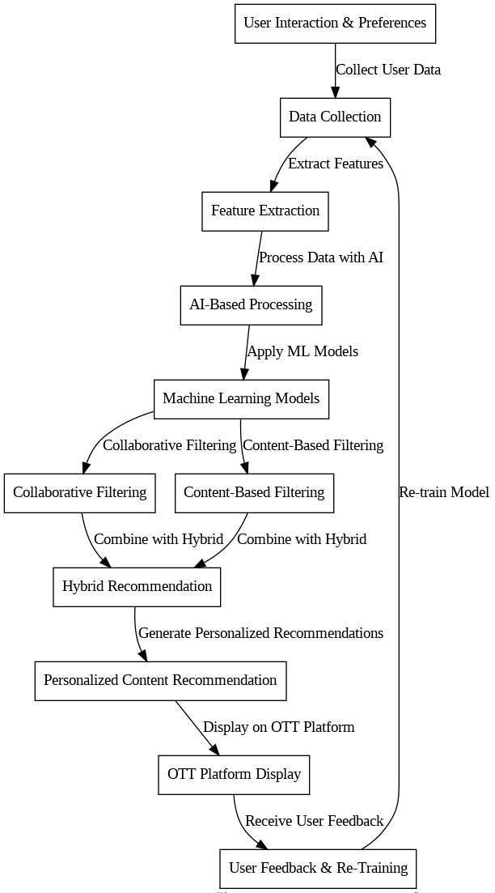

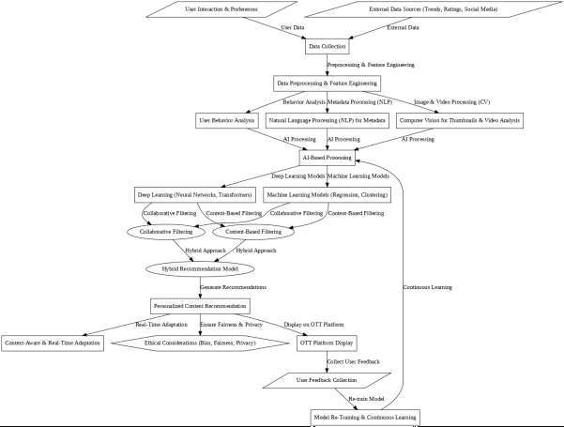

# RESULTS

The comes about of the consider recommend that AI plays a major part in substance personalization, client engagement, and the whole media generation handle. AI-powered proposal frameworks offer assistance hold gatherings of people by coordinating custom-made substance their way. NLP-aided robotized news coverage speeds up the generation of news with diminished human involvement. Games advantage from AI because it increments interactivity through story adjustment and real-time decision-making. In any case, AI media frameworks may too display challenges, like predisposition in substance, deception, or denigration to human creativity.

Ethical concern includes information security, unknowingly controlling the client, and over- depending on algorithmic substance dissemination.The think about emphasizes creating AI frameworks centering on Moral concern includes information protection, unknowingly controlling the client, and over-relying on algorithmic substance dissemination.The consider emphasizes creating AI frameworks centering on transparency, client strengthening, and morally made substance.

# DISCUSSION

# The impact of AI in media isn't as it were confined to mechanization and personalization but too joins human cognition, believe, and decision-induction. Arkhipovaâs consider (2023) presents AI proposal systems as impact variables in client discernment and behavior, hence laying down concerns over advanced reverberate chambers and algorithmic bias.

# The social development of technology (SCOT) clarifies the societal and social shape that shapes AI frameworks, subsequently affecting differing qualities in substance. Moral predicaments that call into address the misuse of AI within the media domain expand to deception and substance control. Deepfake AI and manufactured media put open trust and media unwavering quality at hazard. Consequently, we ought to create administrative systems to ensure dependable AI-mediated media whereas adjusting innovation against moral parameters. Rane et al. (2023) research hyper-

# personalization in CRM, setting up AI as a key calculate in supporting client devotion. Be that as it may, from another point of view, over-personalization raises issues with respect to protection rights, which can as it were be maintained by productive AI administration. The consider too explains on the developing availability war, counting AI discourse input and real-time captioning that engage inclusivity in advanced media.

# CONCLUSION

Undoubtedly, media and amusement businesses have been reexamined by AI, giving prospects for more prominent personalization, proficiency, and group of onlookers request. In spite of contributing emphatically towards shoppers with AI-driven suggestion frameworks, it moreover raises numerous moral and cognitive concerns. The impact of AI on human decision-making requires that those angles included in promoting

ethical advancement center more on straightforwardness, equity, and ethics. Investigate within the future must be pointed at creating AI systems that are congruous with human values, guaranteeing that AI is an enabler of human action and not so much an design thereof. A approach system ought to be put in put to cure the security suggestions of this AI transformation for the media world and guarantee believe between the client and the media.

Therefore, by embracing a human-centered AI approach, the media industry can put AI capabilities to great utilize of upgrading moral measures at the side a sense of welfare.

# REFERENCES

* Prasad, Ramya K., & Makesh, Deepa: Analyze affect on the media and amusement industry, investigating AI-driven substance creation, showcasing, group of onlookers engagement, and moral challenges.
* Chandramouli, Krishna, & Margetis, George: Give

experiences into Human-Computer Interaction (HCI) in different spaces, counting gaming, computerized legacy, and intuitively media

* Arkhipova, Daria: See at the affect of AI proposal systems on human decision-making, emphasizing cognitive, energized, and behavioral influences.
* Singh, Simarpreet, & Singh, Williamjeet: Conduct a capable diagram of AI-based character pine for utilizing substance data, highlighting datasets, highlight choice, and diagram assessment.
* Rane, Nitin, Choudhary, Saurabh, & Rane, Jayesh: Explore hyper- personalization in Client Relationship Organization (CRM) systems, talking almost AI-driven client engagement and dedication strategies.
* Wu, Ching-Seh Mike, Garg, Deepti, & Bhandary, Unnathi: Show a motion picture proposal framework utilizing collaborative sifting, analyzing calculation proficiency and real-world applications.
* Schedl, Markus, Zamani, Hamed, Chen, Cheng, Deldjoo, Yashar, & Elahi, Mehdi: Look at suggestion framework challenges, centering on personalization, adaptability, and client engagement.
* Nanou, Christos, Lekakos, George, & Fouskas, Konstantinos: Think around the influence of presentation techniques in  
  recommender systems on client impact and satisfaction.
* Ahn, Hyeong Jun, & Shi, Yong: Highlight the portion of social metadata in advancing the accuracy of proposal framework
* Kumar, Anand, De, Pradipta, & Roy,

Somnath: Propose utilizing assumption

analysis from microblogging information to

enhance personalized proposals.

* Beel, Joeran, Gipp, Bela, Langer,

Stefan, & Breitinger, Corinna: Center

on reproducibility and assessment

techniques in AI-driven recommender

systems.

* Liu, Dong, Choi, Jonghyun, & Liu,

Qiang: Examine profound learning models

in personalized motion picture suggestions,

emphasizing neural systems and crossoverfiltering procedures.